6.2.3. Implementation of e-governance in areas of operation
- Administration
- Finance and Accounts
- Student Admission and Support
- Examination
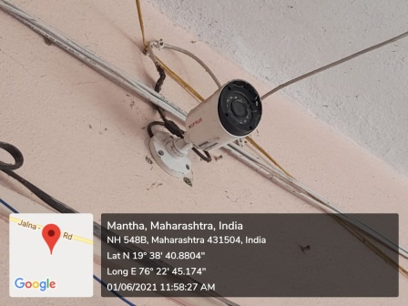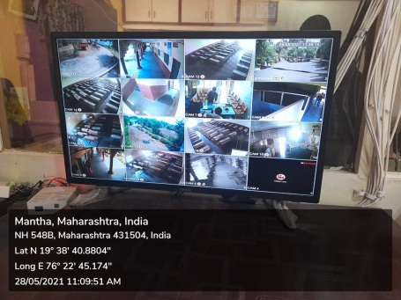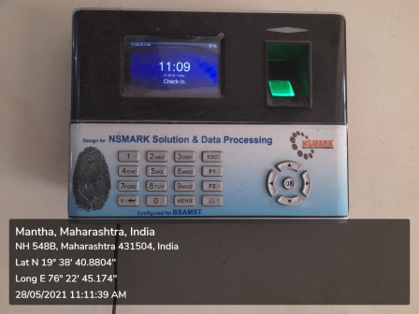
CCTV camera CCTV Screen Thumb machine

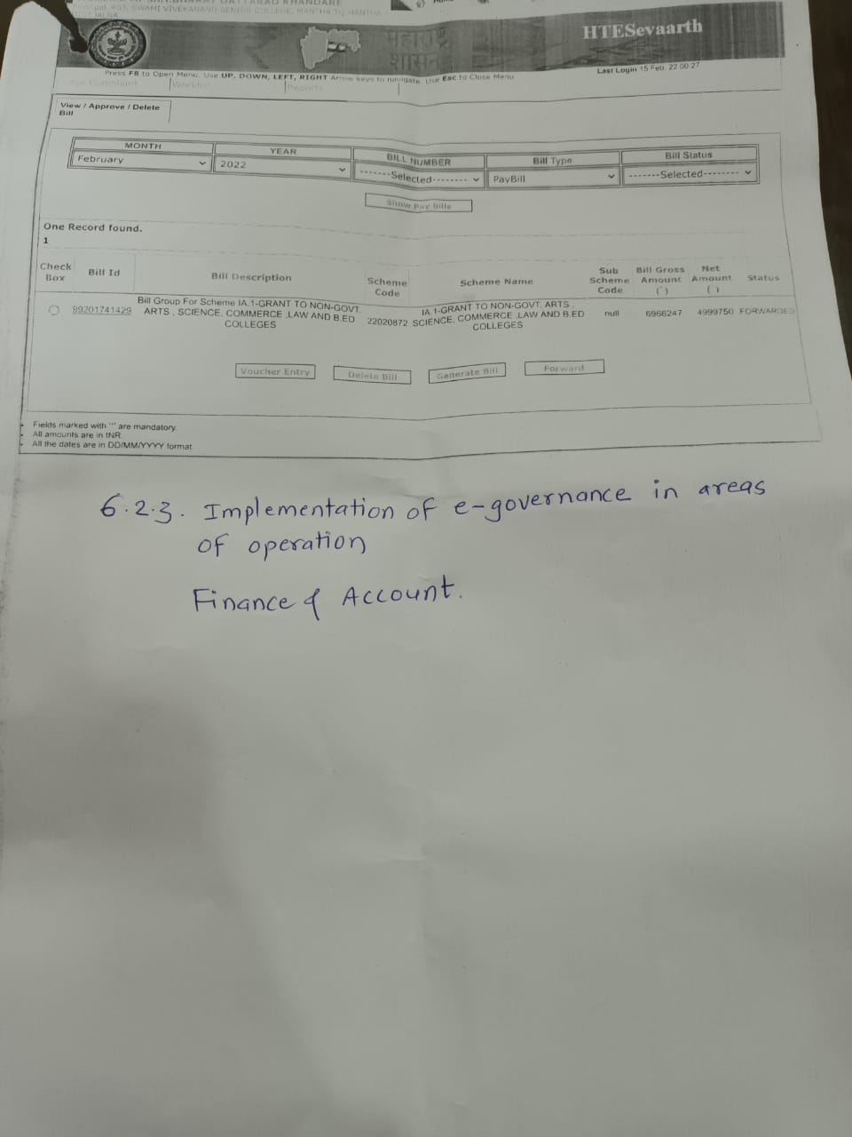
2. Finance and account

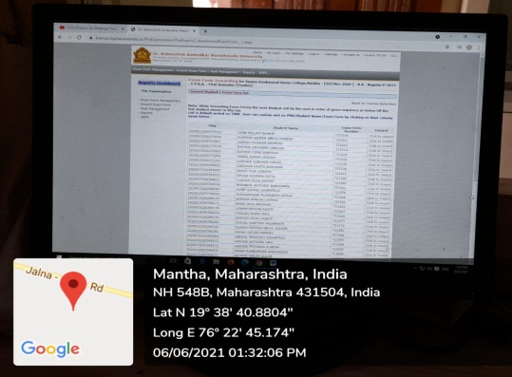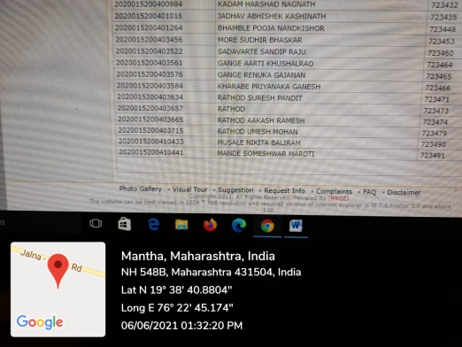
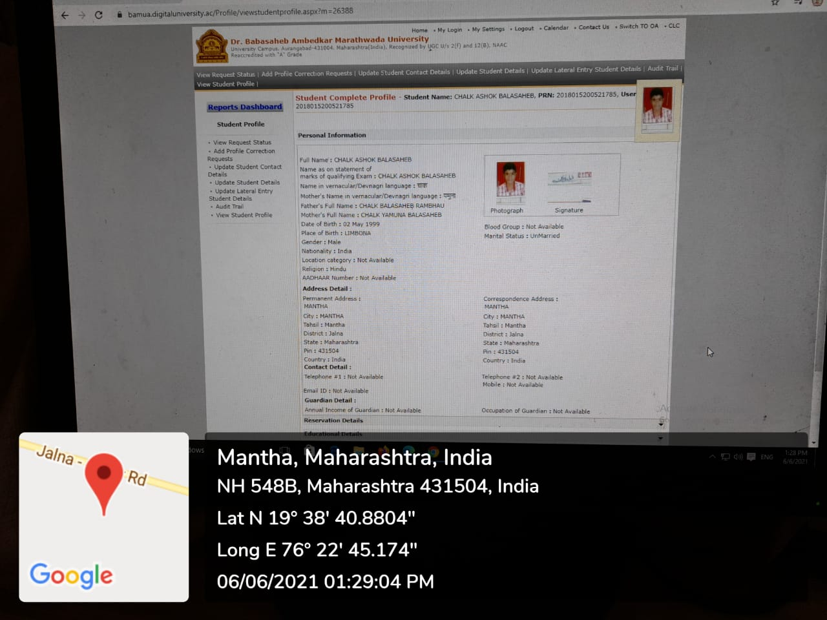
3. MKCL for Student Admission and Support
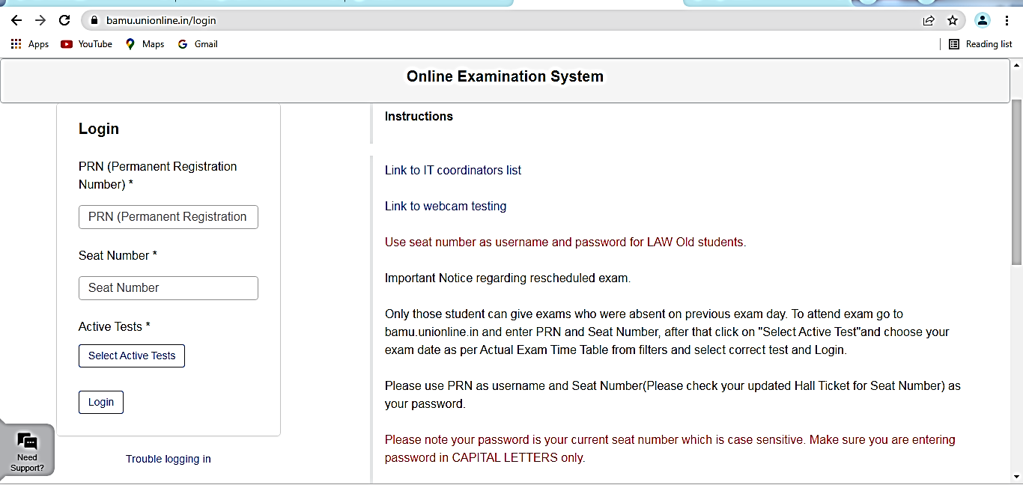
Online examination system of Dr. BAMU, Aurangabad
https://bamu.unionline.in/login

