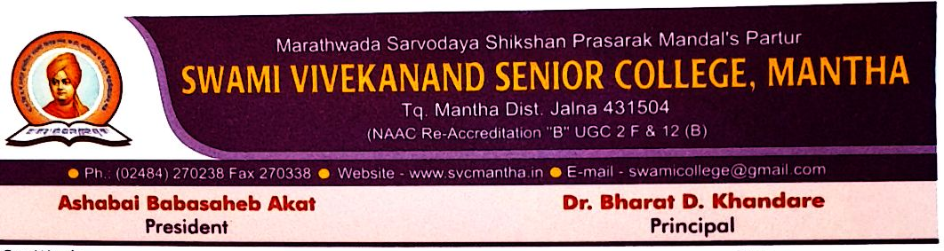

3.4.3: Number of extension and outreach programs conducted by the institution through NSS/NCC, Government and Government recognised bodies during the last five years

Year | Link of the event
2015-16 | https://svcmantha.in/storage/2022/04/NSS-2015-16.pdf
2016-17 | https://svcmantha.in/storage/2022/04/NSS-2016-17.pdf
2017-18 | https://svcmantha.in/storage/2022/04/NSS-2017-18.pdf
2018-19 | https://svcmantha.in/storage/2022/04/NSS-2018-19.pdf
2019-20 | https://svcmantha.in/storage/2022/04/NSS-2019-20.pdf

