3.4.1: Extension activities are carried out in the neighborhood community, sensitizing students to social issues, for their holistic development, and impact thereof

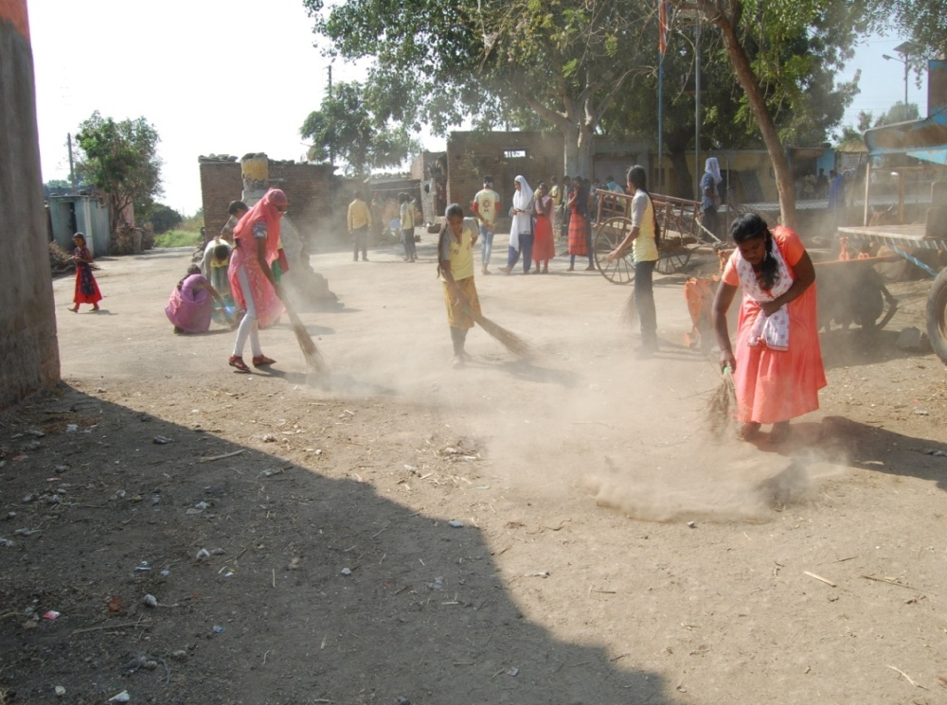
Swacch Bharat Abhiyaan

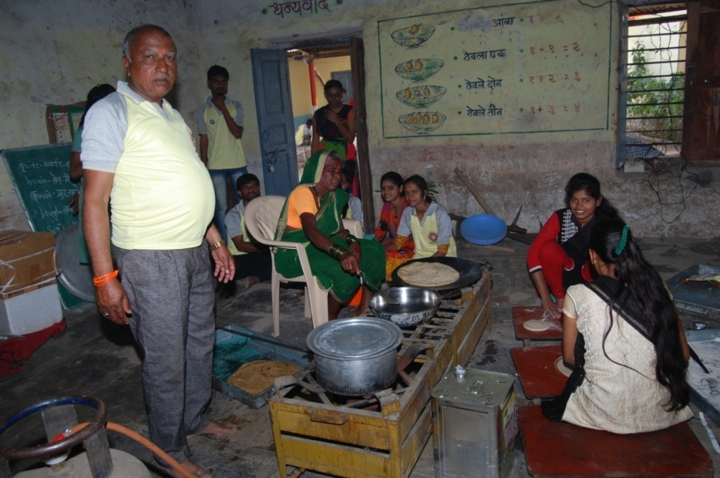
NSS Volunteers helping in Coocking

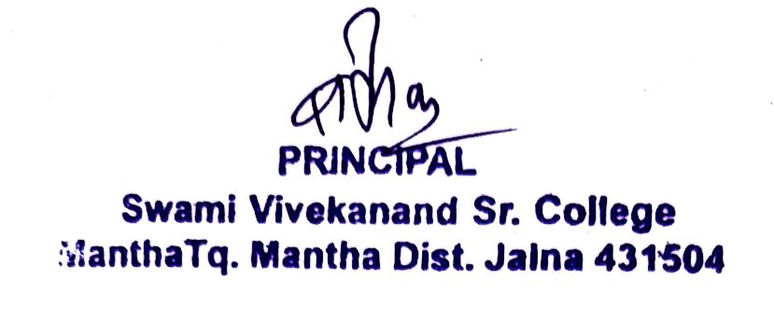

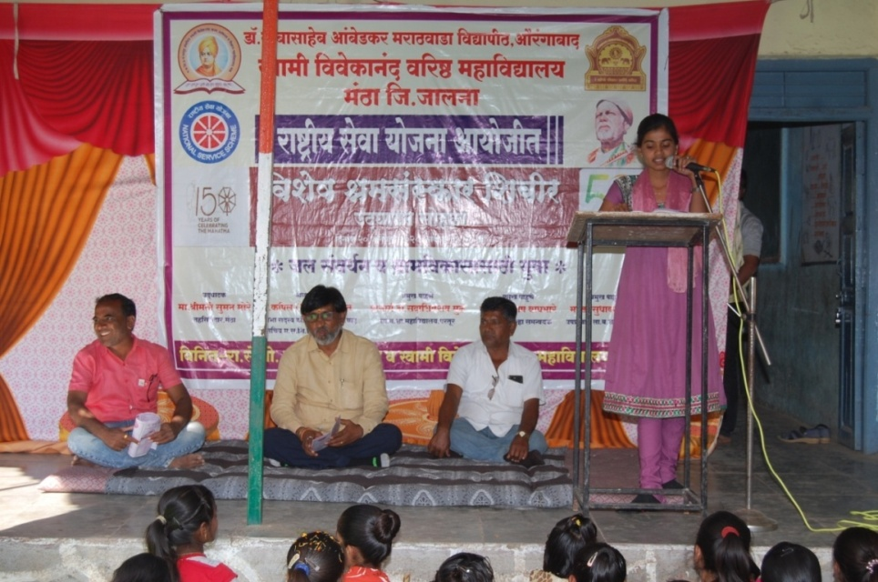
NSS Volunteer Sakshi Ghanvat Anchoring Session of NSS

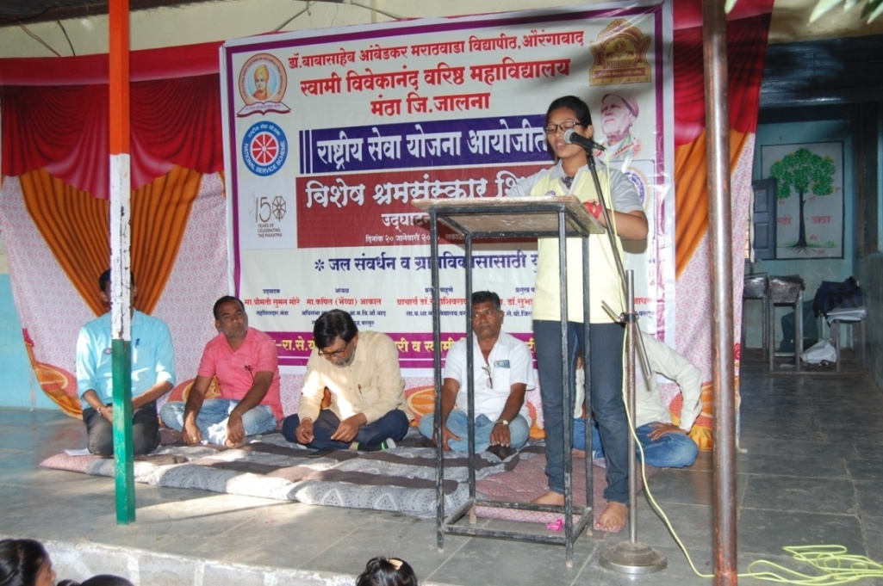
NSS Volunteer Maya Jadhav proposing vote of thanks of session

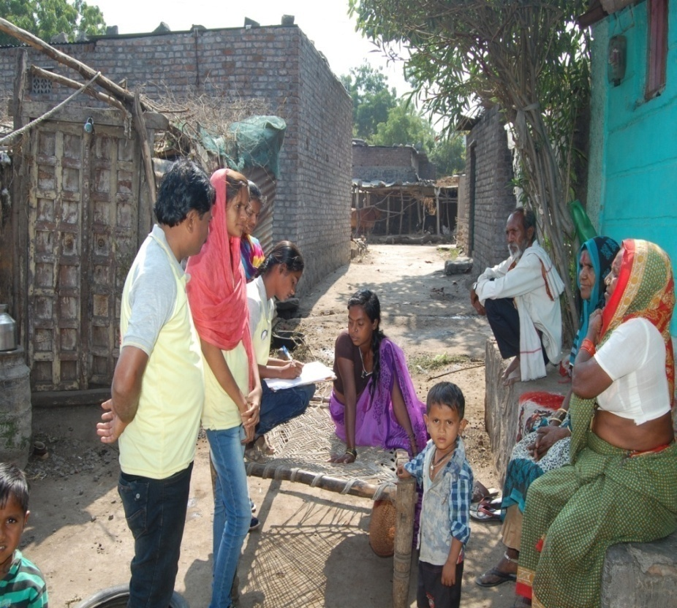
NSS Volunteer survey to know community problem

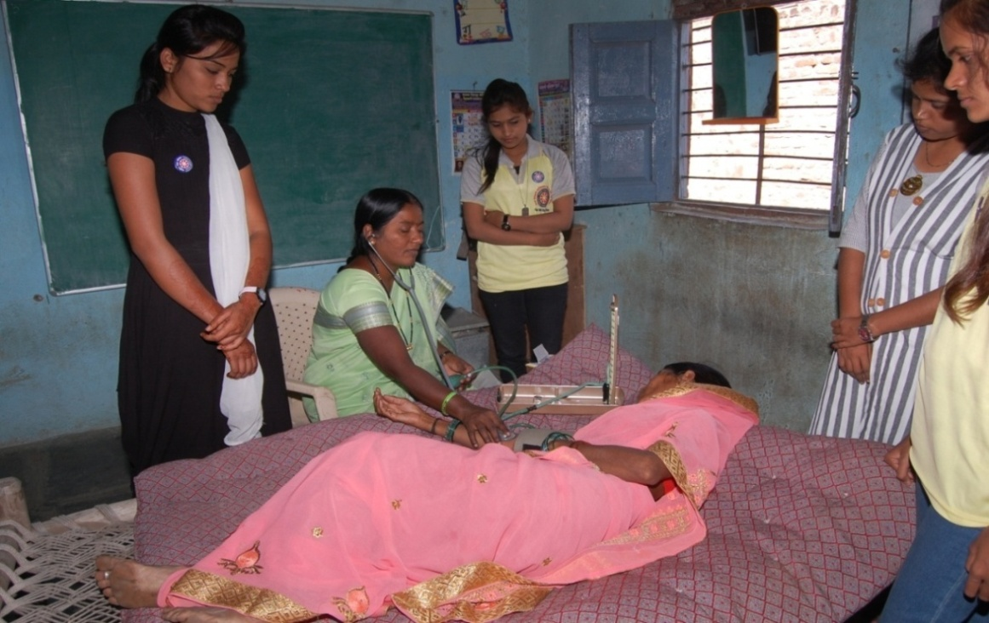
Women health check up and NSS volunteers Priyanka Dhakarge, Snehal Kakde, Ashwini Deshmane and Vijaya Pokharkar

